You are required to use database named [EmployeeDB](https://docs.google.com/document/d/1QUQQIfsvui-UWpkqRKlvt84MV_anpYaXWZxwI939A6o/edit?usp=sharing) to be able to answer the below questions:

Create a AddProjectMember.aspx page

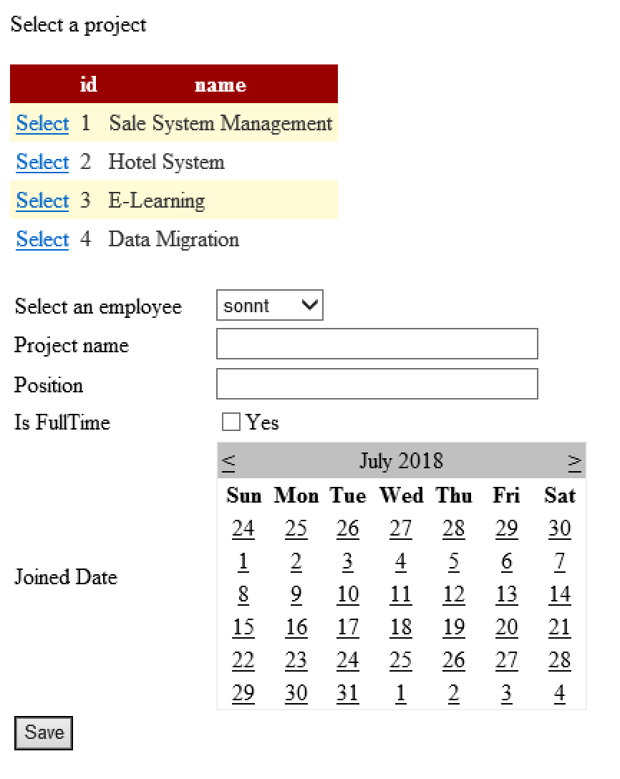

Requirement:

* Bind data of Project table to gridview control.
* Bind data of Employee table to dropdownlist control, display employee name.

When users select a project from gridview, output selected project id to textbox.

When users enter information of a projectmember and click save, save information of projectmember to projectmember table.

